Low UI and High UI Designs-Dhruv Kumar

Figma Link: https://www.figma.com/file/oESxKDryEkgYtst6vboE3W/Untitled?type=design&node-id=0%3A1&mode=design&t=WyxeIWr5ciPupZvS-1

Low UI Design

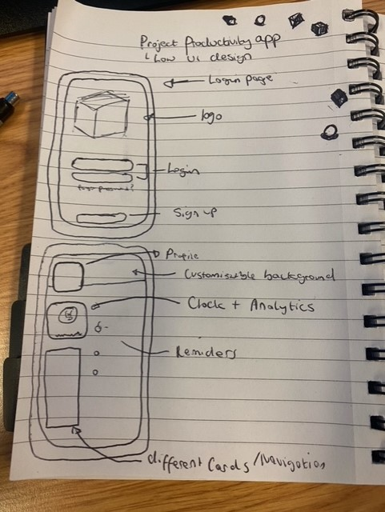Above I have created a low ui design with each of the components that function in the app, the user will be able to customise the app to their liking and navigate the app with one gesture.

High UI Design

I decided to go for a very minimalistic design, as this would make the app easier to use and efficient. The home page consists of a simple design where users can add features such as reminders, notes, statistics etc. On the right I have added a card features where the user can navigate to other areas of the app the user has created. For example, if the user wanted a dedicated gym page where they can track the sets, calories, time etc they can view it independently without cluttering the page.

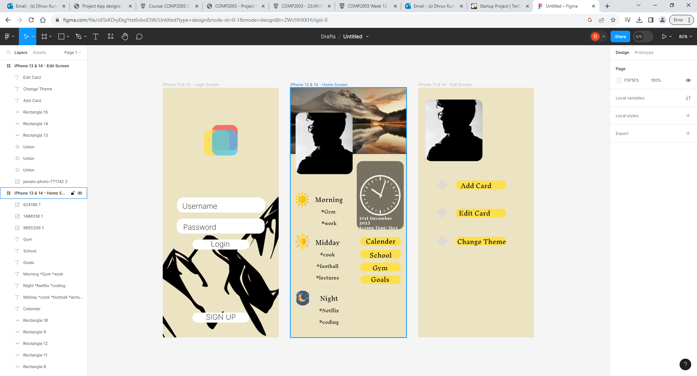

During one of the meetings, I discussed the design aspect of the app, coming from the feedback my group felt that the design aspect was simple and easy to use however the colour choice could be better. Considering this I decided to change the colour choices and created the design above. Although the design will be customisable by the user i decided to change the default design after Feeback from the group.